**Thought For The Day – December 2021**

*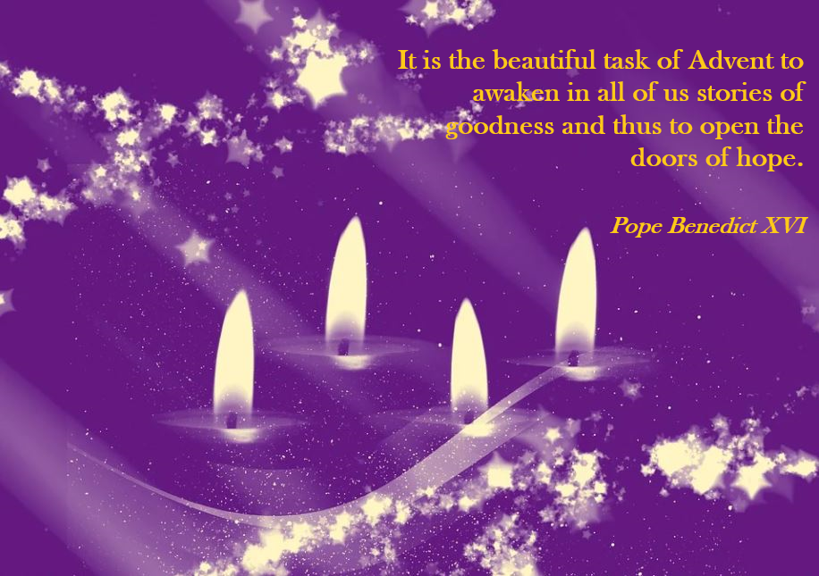  
December 1st – Advent*

*  
December 2nd – International Day for Abolition of Slavery*

*  
December 3rd – International Day of Persons with Disabilities*

*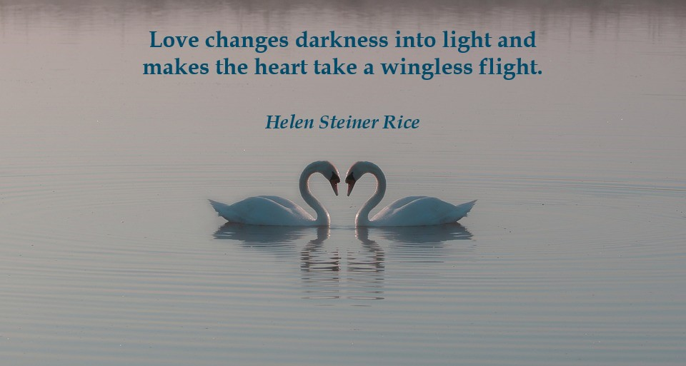  
December 4th*

*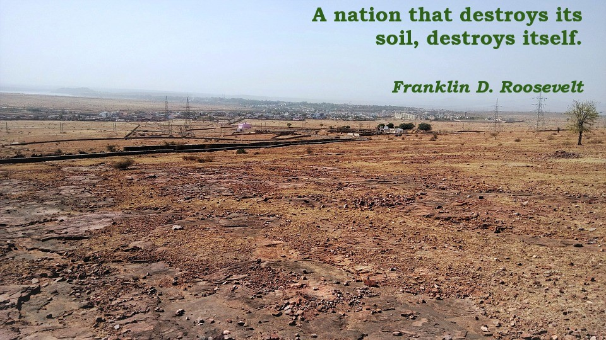  
December 5th – World Soil Day*

*  
December 6th*

*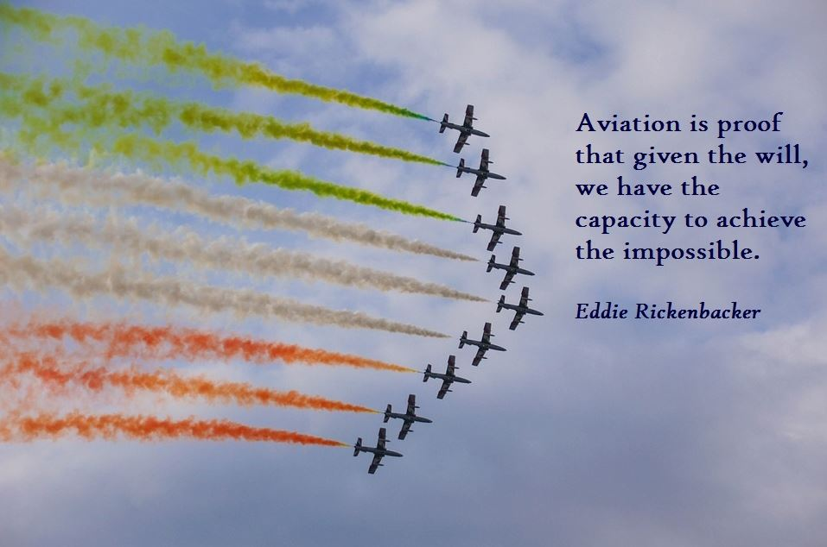  
December 7th – International Civil Aviation Day*

*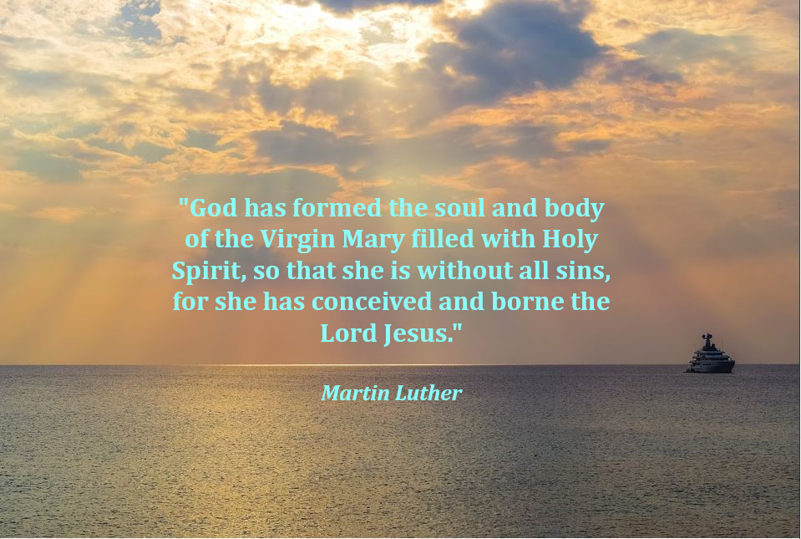  
December 8th – Feast of the Immaculate Conception*

*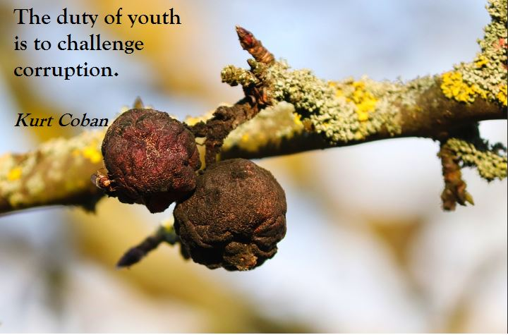  
December 9th – International Anti-Corruption Day*

*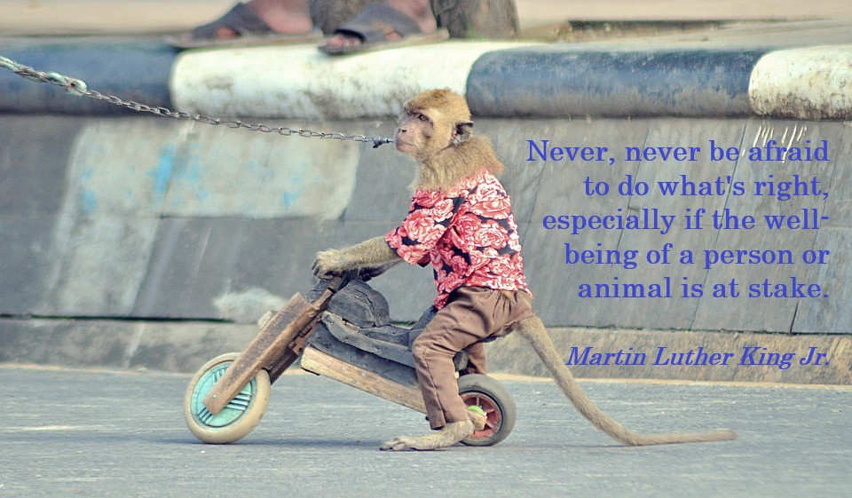  
December 10th – International Human and Animal Rights Day*

*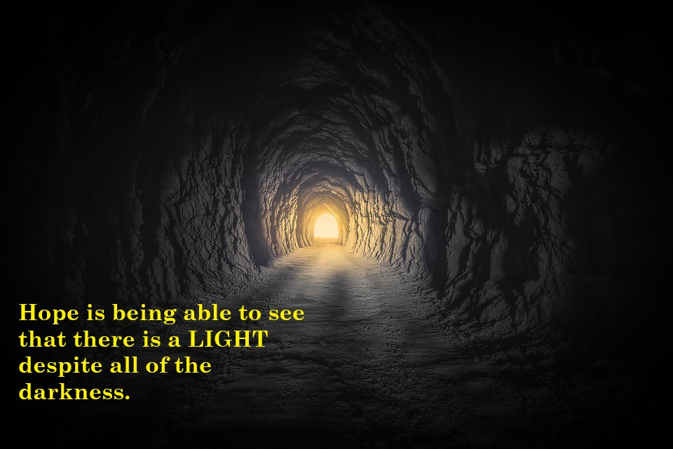  
December 11th*

*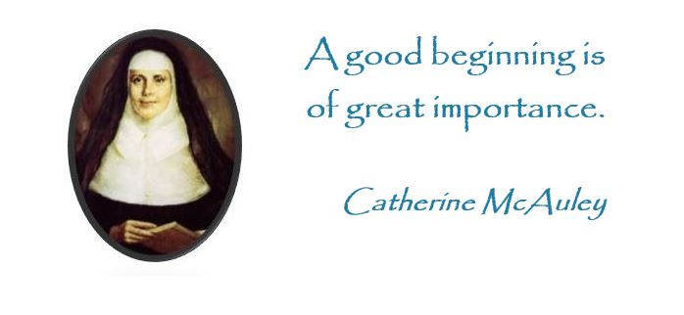  
December 12th – Mercy Foundation Day*

*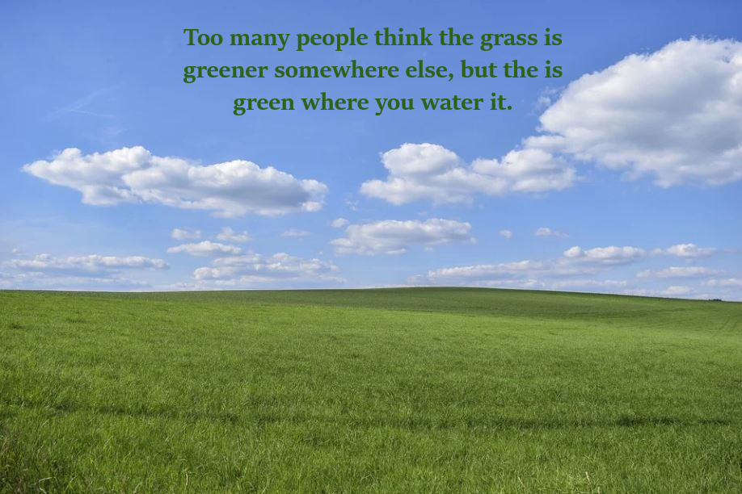  
December 13th*

*  
December 14th*

*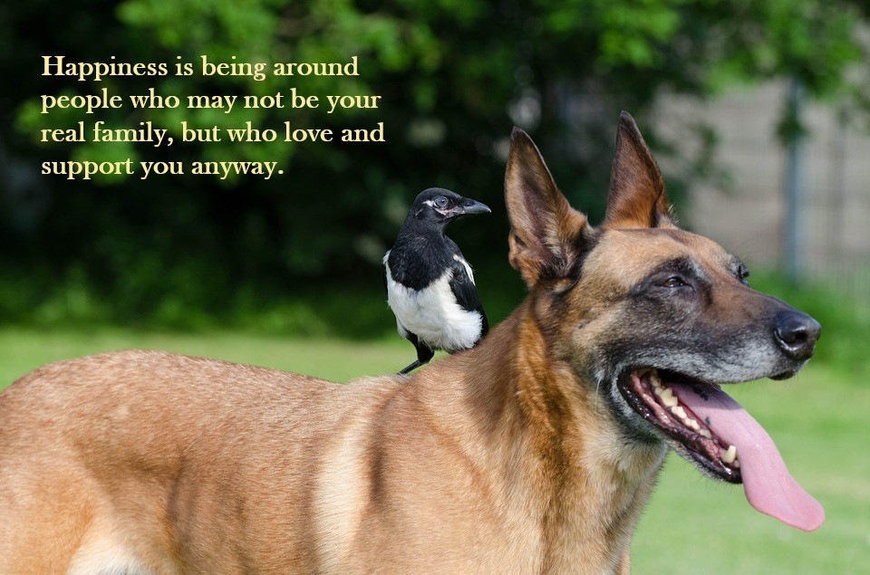  
December 15th*

*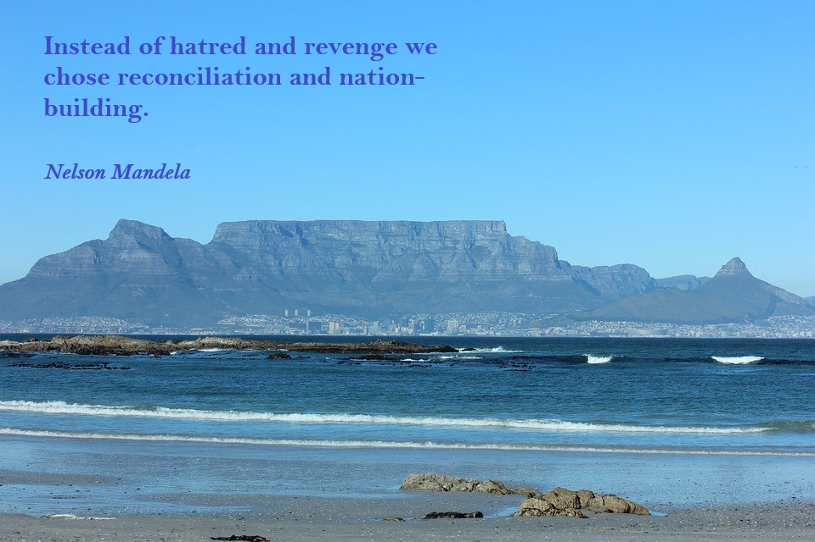  
December 16th*

*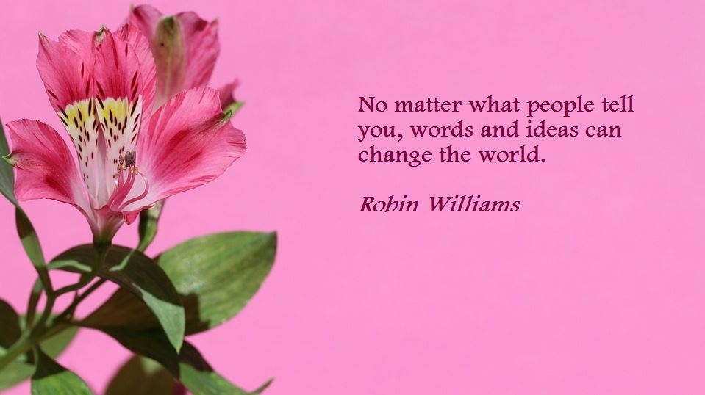  
December 17th*

*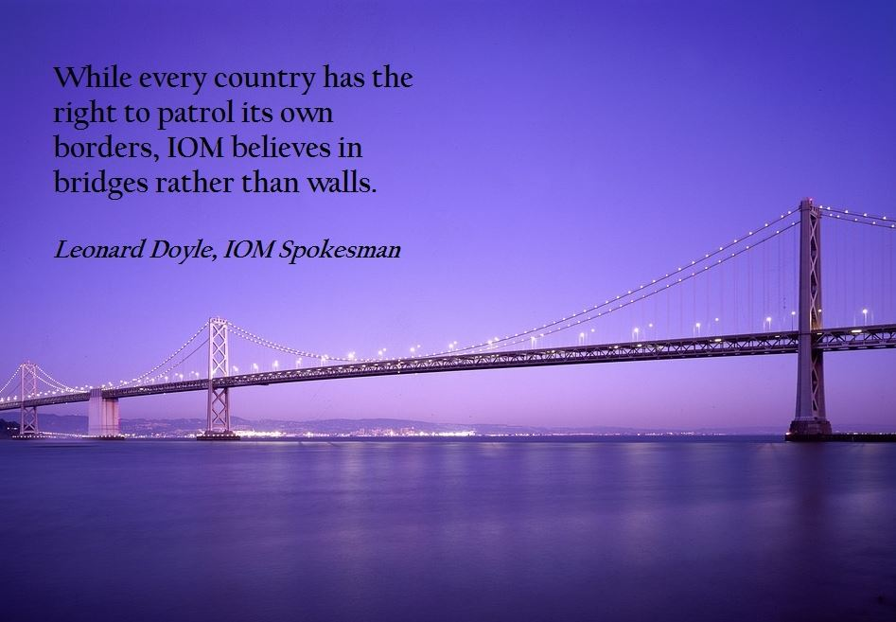  
December 18th – International Migrants Day*

*  
December 19th*

*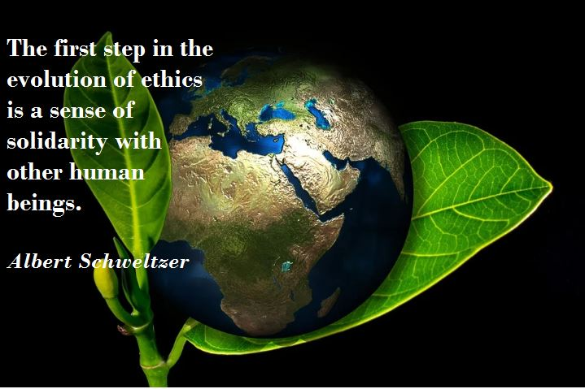  
December 20th*

*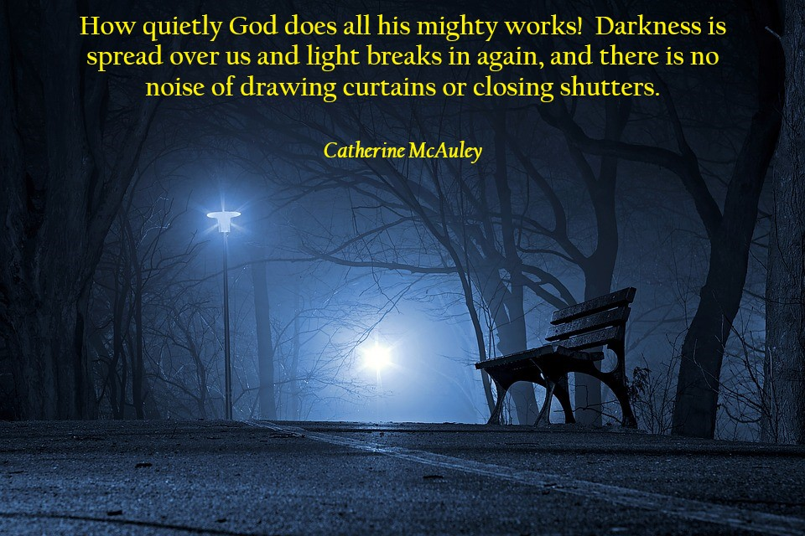  
December 21st – Winter Solstice*

*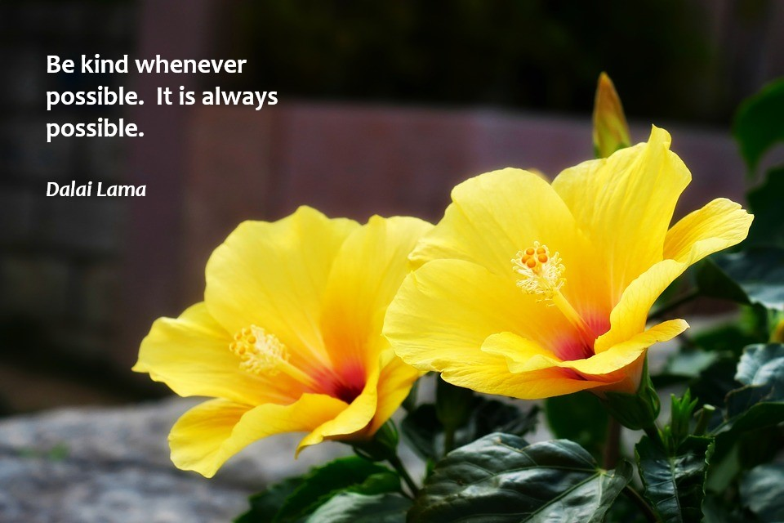  
December 22nd*

*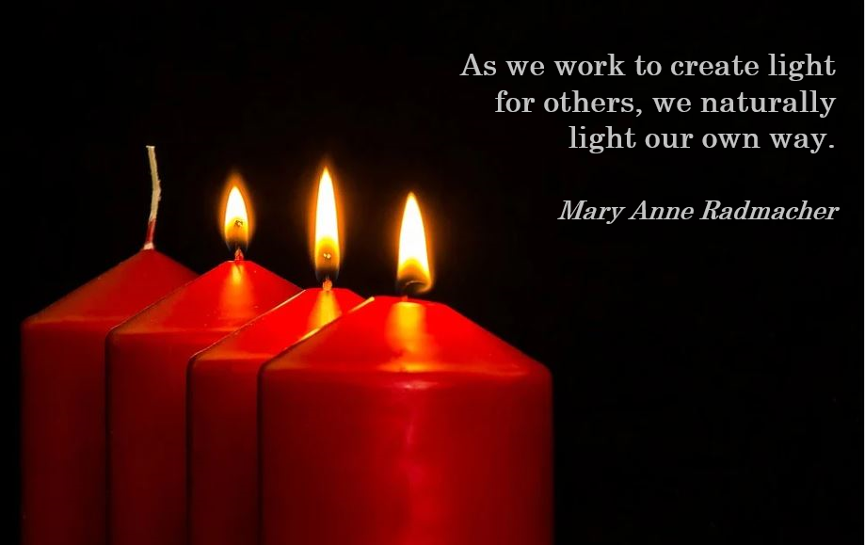  
December 23rd*

*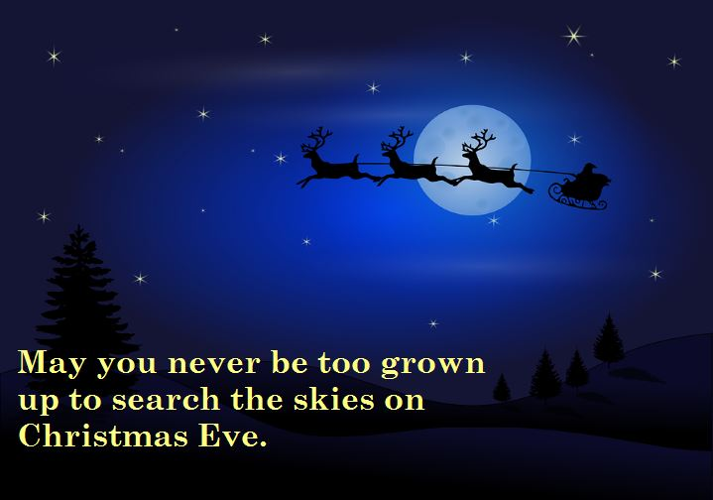  
December 24th – Christmas Eve*

*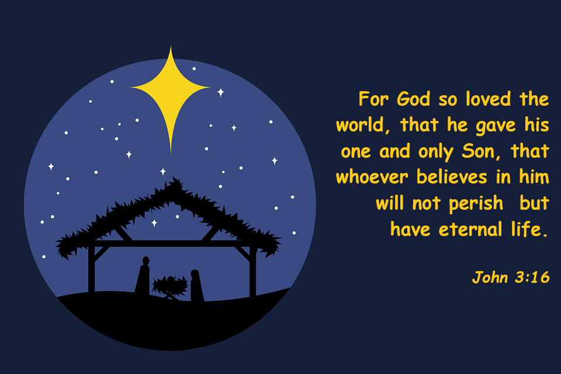  
December 25th – Christmas Day*

*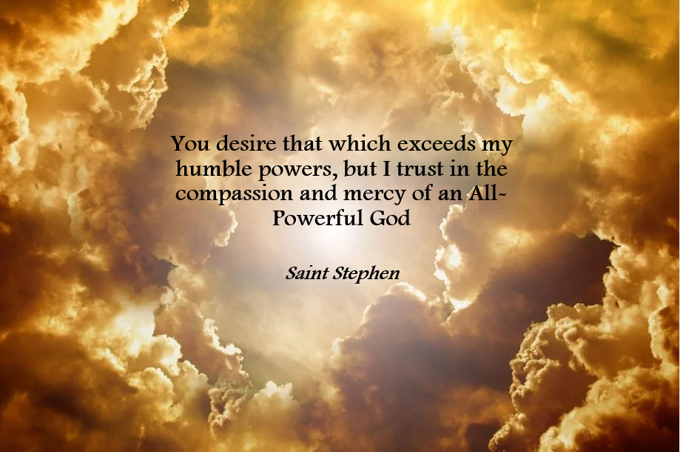  
December 26th – St. Stephen’s Day*

*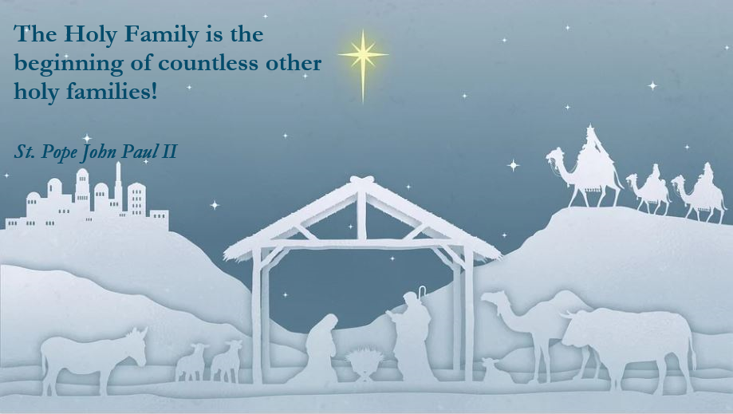  
December 27th – Feast of the Holy Family*

*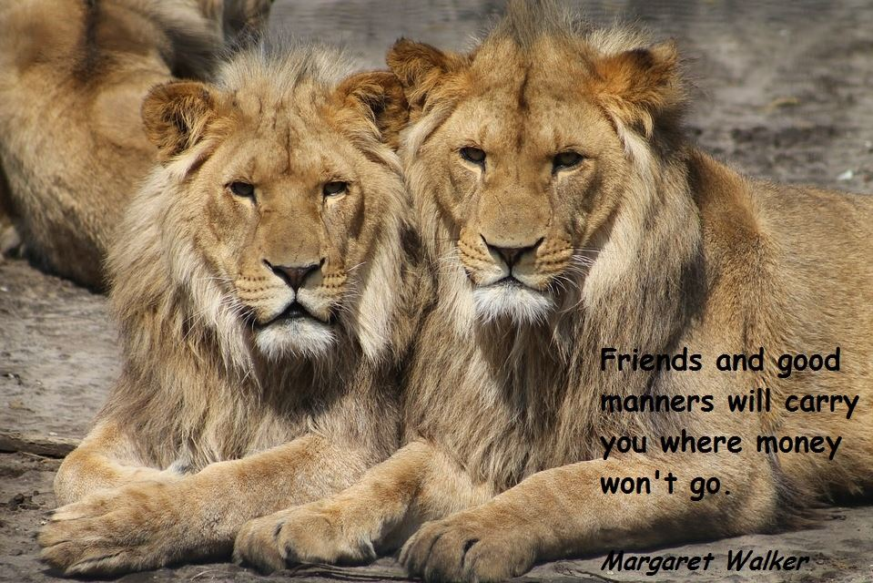  
December 28th*

*  
December 29th*

*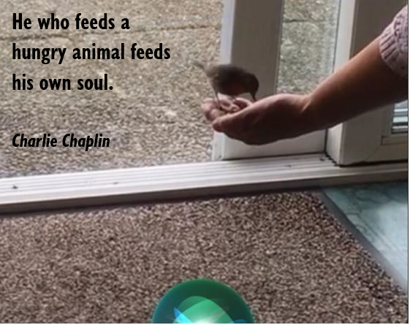  
December 30th - Photograph courtesy of Mary Freeman, Southern Province*

*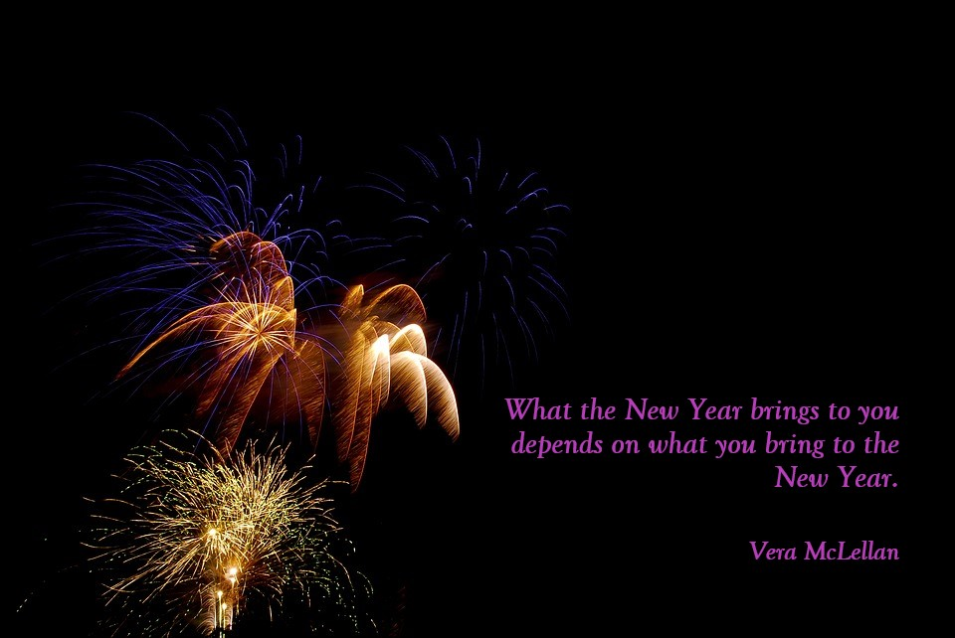  
December 31st – New Years Eve*