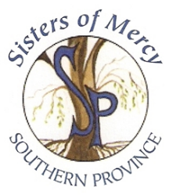

**Our Safeguarding Children Structure**

**Local Support Persons:**

**Maura O’Flynn**

**&**

**Isobel Flynn**

Support the Complainant.

**Local Advisers:**

**Pauline Tallon-Collins** Advise/Support   
the Respondent.

**Local Safeguarding Representatives**

Raise awareness and promote best practice.

**Safeguarding Committee: Chair: PJ Daly Secretary: Kate O’Connor, Brid Biggane RSM (PLT) Tom Murphy Maria McGuinness RSM, Darius Whelan, Honor O’Shea &**

**Silvia Marie Crowley**

Oversees the implementation and monitors the application of the 7 Standards in the life and mission of the Province. They audit the implementation of the 7 Standards.

**Provincial Leader: Eileen O’Flynn**

Exercises personal authority throughout the Province and has overall responsibility for Safeguarding Children and Vulnerable Persons at risk of abuse Structure within her Province.

**Safeguarding Manager: Cleo Yates**

Oversees the Safeguarding Structure and ensures that it serves the 7 Standards, is responsible for creating, maintaining and monitoring a safe environment for all aspects of best Safeguarding Practice in the Province and Safeguarding Committee meetings.

**Designated Liaison Person: Cleo Yates &**

**Deputy Designated Liaison Person: Kate O’Connor**

Manage Response to Allegations from Start to Finish.

Case Management

**Designated Trainers – Cleo Yates and Kate O’Connor**

Offer training to those who have significant contact with Children and Vulnerable Persons at risk of abuse on a regular basis (at least every 3 years).