A Postulators Diary
It is now several years since I first started this ministry as Postulator of the Cause of our Foundress Venerable Catherine McAuley.
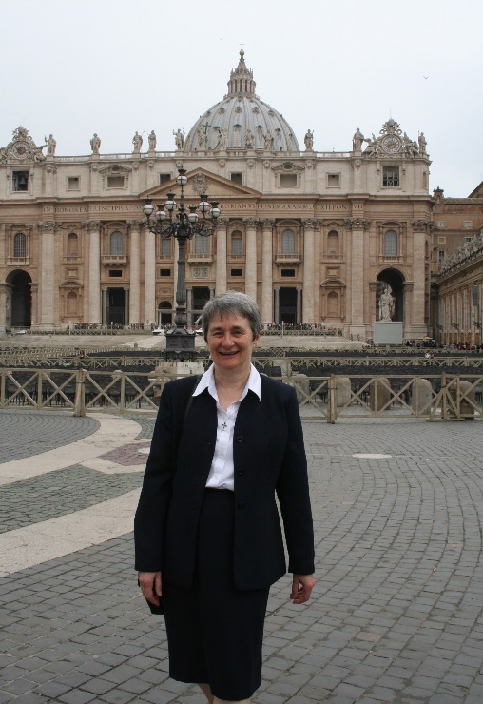
Father Martin Nolan, who had been the Postulator for more than twenty years, resigned his position in May 2006 and Angela Bolster rsm who had worked with him as Vice Postulator and with two other Postulators before him, had already gone to God since February 2nd 2005.
In the first heady days of learning what it meant to be a Postulator, I found the ‘Studium’ course (training for Postulators run by the Congregation of Causes in Rome) interesting and stimulating. The course has four sections: one deals with the Church’s understanding of Holiness as expressed through the lives of the Saints. Secondly, there followed the history of hagiography (lives of the Saints) and the final two sections dealt with the juridical and canonical requirements for preparing and presenting the Cause as it moves progressively through the phases of (i) declaration of holiness of life (Venerable), (ii) beatification (local vereration) and (iii) canonisation (universal veneration). The material in relation to holiness of life is gathered into a book called the ‘Positio Super Virtutibus’ and the materials gathered for beatification and canonisation respectively are found in the ‘Positio Super Miraculis’.
In April of 2007 the first meeting of the World Mercy Committee for the Cause for Beatification of Catherine McAuley was held in Mercy International Centre in Baggot Street, Dublin. The purpose of this gathering was to bring a representative from all the Mercy Congregations around the world together, face to face, in order to share what was happening about the Cause in their respective places and to plan for working together as a group into the future. Up to this time the other Mercy Congregations had now been actively involved in promoting the Cause which is essentially the responsibility of our Congregation (because Catherine lived and died in Dublin). On this committee we have a Mercy Sister from the three Congregations in Great Britain; the Union, the Institute and the Federation. We have a Sister from Newfoundland, Philippines and New Zealand and we have a Sister from the Americas, Australia and Ireland. That makes ten of us on the committee including myself. As a group we keep contact on a bi-monthly basis by conference call and we talk and share what is happening in the different places in relation to Catherine and the charism of Mercy.
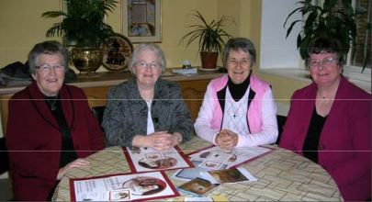
At this time too, three Vice Postulators were appointed to co-ordinate the work in their respective areas of Australia, New Zealand and the Philippines (Sr. Mary Duffy), the Americas, North and South and Canada (Sr. Sheila Carney) and Europe and Africa (Sr. Anne Hannon). (pictured right)
I spent all the summer of 2007 in Rome trying to get to know what the ministry was about, gathering together materials belonging to the cause that Fr. Martin Nolan had stored in St. Patrick’s, the Irish Augustinian house in Rome. These materials had to be ordered and filed and sent back to the Congregational Archive in Dublin. I also began to gather together and file reports on all the alleged miracles and favours received though Catherine’s intercession which had been reported and investigated up to 2007. I sought advice from the Congregation for Causes about them and the feasibility on the following through on some of them. From that time until now I have worked on about twenty five such cases. Many of them had been there since the time of my predecessors but I have worked actively on at least ten which were sent in to us over the years.
In the time that I have been in this ministry I have learned the following:
- Although we haven’t yet been blessed with a miracle what will bring Catherine to beatification, reading through these stories and touching into the faith and trust so many people have in Catherine’s power of intercession had made a powerful impression on me. I realised very quickly that there are many, many people out there who really love Catherine McAuley, who really appreciate her for her holiness and humanity, for her trust in God and His Providence and for her unfaltering reaching out to those who were in need of any form of care and help all through her life.
- Over the years my colleagues on the Canonisation Committee and myself have become increasingly aware of the power of the charism given to Catherine and shared by all of us. So many people, men and women, from all walks of life find nourishment and consolation, challenge and inspiration in the life and work, the words and deeds of this intrepid daughter of Dublin. The confident simple was that Catherine communicates her love of God, together with her practical unassuming way of helping others is very catching. Colleagues and collaborators, associates and friends, are taking the charism forward into a new era. In new ways and with a fiery enthusiasm. Visits to Catherine’s tomb (pictured left) and home, symposia and conferences, letter readings and story circles, prayer gatherings and children’s plays are only some of the many sources that inspire joyful Mercy living that we have encountered. An audio CD on the Letters of Catherine is available. This CD opens a window into her soul and heart and highlights her relevance for our present day world. Our latest project is a documentary drama on Catherine’s life called In God Alone.
- The requests for prayers and the letters of thanksgiving that come to the Vice Postulators from people all around the world testify that Catherine is known and trusted far beyond the confines of the religious Congregation that she began nearly 190 years ago. The Vice Postulators are constantly amazed when they open letters and read the requests or stories therein, many from people who are no Catholic but who somehow are certain that Catherine will care for them.
- One of the best things, personally, to come from my time so far as Postulator is the chance it gives to come to know Catherine better, seeing her through her own words and way of living and also seeing her through the eyes of others. Catherine’s pithy description of what being a woman of Mercy is ‘an ardent desire to be united to God and serve the poor’, sums up much of who Catherine was and of the reason why people find it so easy to identify with her today. Without Catherine’s power so many women could never have linked their own search for God with the care and education of the poor. For all who know her and share in her spirit, Catherine is a living powerful symbol who nourishes spirituality and goads people to undertake activities for the relief of the poor that will long outlive them. The purpose of our Mercy charism has always been service no matter what shape or form our living takes.
- As we continue into the future, our hearts filled with joy and hope, we pray that knowledge of Catherine and her spirit of Mercy will continue to spread and deepen so that when the time comes for her beatification we will through her example and intercession be even more deeply imbued with love and God and loving service of the poor.
I finish with a prayer that reminds me of Catherine (though not written by her), her gentleness and complete self-donation, her breath of vision and courage, her humanity and great Love.
May a secret Providence guide your thought and encradle your feeling
May the sense of something absent enlarge your life
May you succumb to the risk of growth
May you belong to Love with the wildness of dance.
Brenda Dolphin rsm
Postulator

